# Dataset Description

## Dataset Overview

**Organization Name:** SZMC

**Number of Records:** 1005

**Data Domain:** Cardiology

## Cohort Characterization

**Number of Distinct Patients:** 709

**Medical Indications Covered:** clinical background of patients that were hospital at cardiology

## Text Content Details

**Minimum Text Length (total terms):** 12

**Average Text Length (total terms):** 188.98

**Maximum Text Length (total terms):** 1387

## Dates

**Date Range of Records:** 2014-01-03 to 2017-05-04

## Data Source

**Original Data Source:** azma

## Language Analysis

**Hebrew Count:** 893

**English Count:** 0

**Mixed Count:** 112

**Hebrew Ratio:** 88.86%

**English Ratio:** 0.00%

**Mixed Ratio:** 11.14%

*Note: Mixed texts are classified as such when more than 10% of the text words belong to a secondary language.*

## Distribution of Text Lengths

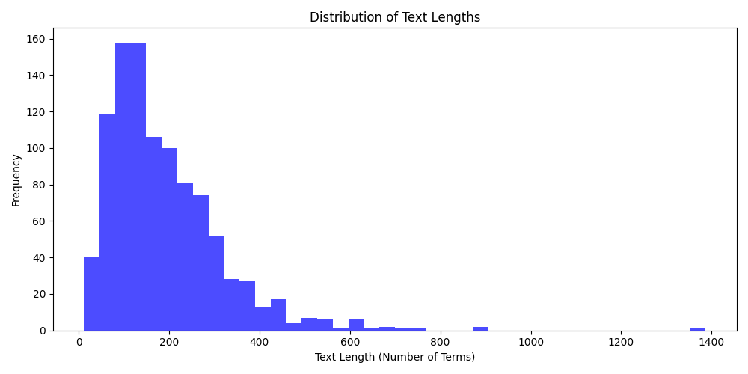

## Distribution of Record Dates

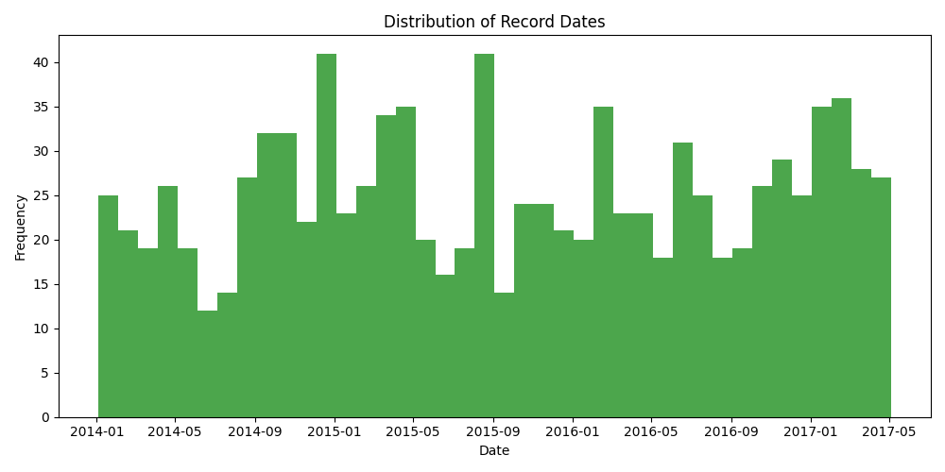

## Language Distribution

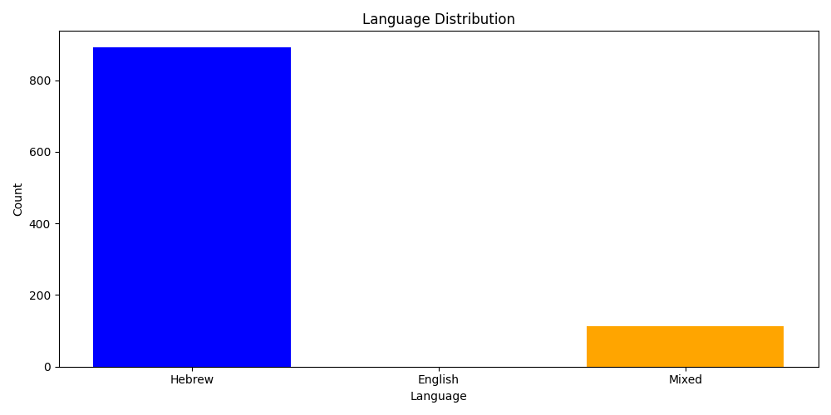

*Note: Mixed texts are classified as such when more than 10% of the text words belong to a secondary language.*